
COMPANY PORTFOLIO
COMPANY NAME: | EXCELLENT EXPRESS SERVICES SDN BHD
COMPANY REGISTRATION NO: | 819695 U
BOARD OF DIRECTORS: | JAGATHIVARI A/P BADIWELLO  AMINAHBI@MEENATCHI A/P PITCHAGANI
MANAGER: | VIJAYAN A/L KUNJURAMAN
ADDRESS: | 751-B JALAN SULTAN AZLAN SHAH, SUNGAI NIBONG,  11900. BAYAN LEPAS PENANG
TELEPHONE: | 04-6439536 / 04-6437352
FAX: | 04-6437359
WEB PAGE: | http://www.excellentpg.com
EMAILS: | vijay@excellentpg.com & jeya@excellentpg.com
BANKERS: | RHB BANK, SUNGAI DUA. PENANG
ACCOUNT NO: | 2071 30000 25172
MAIN CLIENTS: | DELL COMPUTER ASIA PACIFIC SDN  E-WASTE MANAGEMENT  JABIL GLOBAL SERVICE  DUFU INDUSTRIES SDN BHD  MS WAWASAN (PG) SDN BHD  CONTINENTAL VDO COMPONENTS  IPG METAL SDN BHD  SWISS PROFILE (M) SDN BHD  ZD TECH CORP SDN BHD  DHL AIRFREIGHT  FEDEX (M) SDN BHD  UPS (M) SDN BHD  TNT (M) SDN BHD

MISSION AND VISION

Excellent Express Services specialized in our Import Permit Application, supported by qualified professional, consultants and dedicated employees have over 13 years of experience to ensure implementation and successful job done.

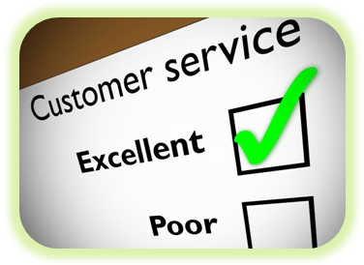
Our client’s satisfaction and success is of paramount importance and vital to us. Our mission is to provide our customers with fully tailored services and attention assuring a mutually beneficial business relationship for all the parties involved.
Listening and responding to our client's needs differentiates us in a competitive and fast paced environment. We strive and take pride in offering our clients the best products and services for today and the future.
At Excellent Express Services we pledge to:
- Provide prompt and courteous customer service
- Respond effectively and efficiently to our client's needs
- Offer a highly specialized and qualified team
- Be an industry leader
We are confident that our services will surpass your expectations giving way to a long lasting partnership.
Excellent Express Services delivered significant and measurable results in the integration space for a range of national and international clients.
Our belief is that the greatest challenge for any integration project is understand the data flowing between the systems. We have long held belief that the conversation between systems should not be focused on low-level systems and protocols.
- Ensure an appropriate level of security attention, relevant to the respective entity's asset protection needs and risk exposure.
- Planning appropriate tools to measure the progress of activities related to the project given.
- Maintain regular interface with business management and customer group representatives to ensure success and support of key business processes, issues and needs.
- Document a security self assessment for security purpose.
- Keep a close communication relationship at anytime with our customer to update information of security issues or changes.

OUR SERVICES

Application of SIRIM License
One of the activities carried out by Excellent Express Services is the processing an approval of import permits for all communication equipment such as telephones, modems, hand – phones, facsimilies, walkie- talkies, etc.
SIRIM QAS International (A / P Approval)
A certificate of approval is required. To obtain approval, the following are needed:-
- An official application letter
- Invoice or bill or loading from shipper / consignor
- E-permit Application Form
- Product catalogue or brochure
- Enter the Sirim product certification scheme / Sirim batch testing scheme an use Sirim label

CUSTOMER
COLLECTION OF INVOICE

SORTING THE INVOICE

APPLICATION OF PERMIT

SUBMISSION TO AUTHORITIES

REJECTED APPLICATION
APPROVED APPLICATION


NOTIFY CUSTOMER
HANDOVER TO CUSTOMER

SURUHANJAYA TENAGA

APPLICATION OF JBE APPROVAL (SURUHANJAYA TENAGA)

The worldwide market access for electrical products is getting more and more complex. Many manufacturers, trading companies and end users are usually over employed by defining the appropriate certification procedure which allows to place a product somewhere in the global market, or to find out the way in a specific country.

This application applicable is for all type of an electrical equipment such as TV, VCD/DVD player, Hair dryer, Rice cooker & etc.

Treatment of Domestically Produced Equipment

To obtain this approval the following are needed:-

- Test reports from local or foreign laboratories which are acceptable to JBE / DSM
- Invoice or bill of loading from shipper / consignor
- JBE (PE) 3 Application Form
- Product catalogue or brochure

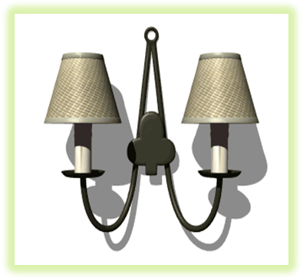


FINAS

APPLICATION FINAS APPROVAL - ( For VCD and DVD)
The National Film Development Corporation Malaysia or FINAS
MADE IN MALAYSIA CERTIFICATION (MIM)
The need for MIM is in accordance with Condition 4 (Additional Conditions) of FINAS Production License, which states:
"A license holder, after completing a commercial film, must apply for MIM from FINAS to certify that the film was produced in Malaysia."
This means that the producers need to apply and obtain the MIM from FINAS after completing the commercial/s and before it is aired. Failure to do so, is an offence according to Condition 4 & 12 of the FINAS Regulation (Licensing) 1983 (Revised 1985) and if found guilty, one could be convicted according to Section 25 of FINAS Act 1981 (Revised 1984).
MIM are given when the commercials are shot locally, and using local expertise and production crews.

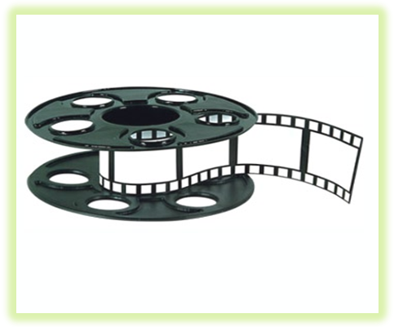
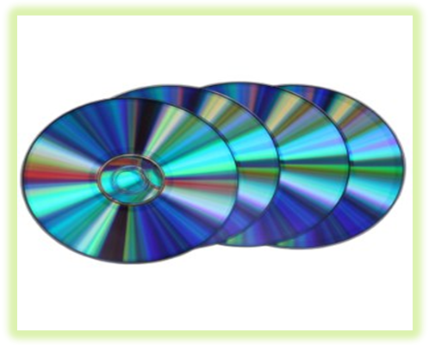

PHARMACY

APPLICATION PHARMACY APPROVAL from Kementerian Kesihatan Malaysia
PERATURAN-PERATURAN LEMBAGA IKLAN UBAT 1976
(Peraturan 8 (1))

Step- by- step Process for Application of Advertisement of products / services
The chart below shows the various stages involved in the processing of an application to advertise a product or service:
Submission of complete application forms & condition

Fulfill the criteria for Fast Track**
Process via Fast Track Procedure (3-5 working days
Yes

No
Closing date of submission
APPROVAL / RESULT
Will be considered for the following month’s meeting
After closing date

Before / on closing date
Process via Normal Procedure (4-6 weeks)

Medicine Advertisement Board (MAB) Meeting

APPROVAL / RESULT

** FAST TRACK CRITERIA:

- Advertisements that have been approved earlier. (The current application should have either no changes or minimal changes from the approved version), or
- Applications coming up for renewal, or
- New applications that do not go beyond the list of indications as approved by Drug Control Authority. The format of the advertisement also stays well within the framework set by the Act and guidelines.





OTHER ADDITIONAL SERVICES
Customs Clearance & Forwarding
- We provide customs declaration and clearance
CUSTOM BROKERAGE
The highly trained and experienced staffs & management team of Excellent Express Services Sdn Bhd ensure fast, efficient, dedication and reliable custom clearance. Our experience in the import & export industries and familiarities with the procedures and requirements (Custom Tariff Code etc.) of the Royal Malaysian Custom and that aboard will allow for the smoothest and fastest of journey for all you inbound and outbound goods.
Dispatching Services – Excellent Express Services Sdn Bhd.
- Paying Bills – At Excellent Express Services we help customers to save their time by taking away the hassle of queuing up and pay bills at the customer. By calling us all your bill payment will be settle for a very little fee.
- Same day delivery for small packages & documents within Penang Island by providing fast, efficient & reliable service.
Transportation and Trucking
We also provide transportation & Trucking facilities throughout Northern Region such as Perlis, Kedah, Penang and Perak with the most reliable and cost efficient trucking and transportation services.
- We do the calling - so you can save your time and money
- We handle all the details to avoid the hassle of dealing with drivers, appointments and pallets
- We can allow you to downsize or eliminate many links of your shipping chain – warehouses, trucks, trailers, railcars, material handling equipment and inventories
- Our carriers’ insurance coverage is monitored daily
- Single invoice from us , no more bills from carriers



